BAR-ILAN UNIVERSITY

Final Project – 83801

Characterization of eye movements under cognitive load conditions in naturalistic environments using  
Virtual Reality (VR)

By:

|  |
| --- |
| Elli Eidelman |
| ID 306679499 |
| Submitted in partial fulfillment of the requirements for the Master's Degree  In the Faculty of Engineering. |

This work was carried out under the supervision of Dr. Yaara Erez

Faculty of Engineering

Table of Contents

1 Abstract 6

2 Acknowledgments 8

3 Introduction 9

3.1 Background 9

3.2 Problem statement 9

3.3 Objectives 9

3.4 Research questions 9

3.5 Significance of the Study 10

3.6 Scope and Limitations 10

4 Related Work 11

4.1 Eye Movement 11

4.2 Identification of Eye Movement Patterns 11

4.3 Use of Virtual Reality 12

4.4 Virtual Reality vs real-world 12

4.5 Gaps in the Literature 13

5 Methodology 14

5.1 Research Design 14

5.2 Apparatus/Materials 17

5.3 Data Analysis 18

6 Results 19

6.1 Descriptive Statistics 20

6.2 Visualization 21

6.3 Hypothesis Testing 24

7 Discussion 31

8 Conclusion 35

9 References 36

10 Appendices 38

Table of Figures

Figure 1 : Gaze Directions with Saccades. 12

Figure 2 : Startup screen, the dice icon will generate a random id. 13

Figure 3 : A toolbox as the target object presented on the near-left side. 15

Figure 4 : A toolbox as the target object presented on the far-right side, next to the closet. 15

Figure 5 : target presented on the far-right with clutter objects presented both near and far. 16

Figure 6 : Data from one session stored in CSV, the most left collum is the path for the trials eye-tracking data. 17

Figure 7 : Participants summary 18

Figure 8 : Data cleaning and change. 18

Figure 9 : Descriptive statistics 19

Figure 10 : Trial duration by clutter and side 20

Figure 11 : Total saccade by clutter and side 21

Figure 12 : Pair plot 22

Figure 13 : Correlation matrix between different measures. 23

Figure 14 : Code snip, T-test for both cases. 24

Figure 15 : T-test results. 24

Figure 16 : Code snip, ANOVA. 25

Figure 17 : ANOVA test results. 26

Figure 18 : Tukey's HSD test results the upper one is trial duration lower is total saccades. 26

Figure 20 : Total saccades by side. 27

Figure 21 : Trial duration by side. 28

Figure 21 : Code snip t-test for each side. 29

Figure 23 : t-test for each side. 30

Figure 24 : logistic regression results on original data. 32

Figure 25 : generating synthetic data based on observed means and SD. 33

Figure 26 : results on synthetic data. 34

# Abstract

In a complex and stimulus-rich environment, attentional processes play a pivotal role in understanding how individuals interact with their surroundings, including both everyday tasks and the operation of human-operated machines. Attention, often regarded as a limited cognitive resource, shapes our perception, decision-making, and actions. This phenomenon extends to the realm of human-machine interfaces, where attention is a critical factor in ensuring efficient and safe interactions.

Attention research has traditionally relied on computer-based experimental paradigms to unravel its underlying mechanisms. While such controlled settings have yielded invaluable insights, it is essential to understand attentional processes in naturalistic environments and real-world contexts. These real-world situations demand a nuanced understanding of how attention operates, as it significantly influences our ability to perceive and act upon our surroundings.

Recent advancements in technology have opened new avenues for exploring attention in ecologically valid settings. Specifically, Virtual Reality (VR) technology offers the creation of immersive, real-world-like scenarios, allowing researchers to investigate human behavior and cognition in more naturalistic contexts. Beyond its applications in attention research, VR has been utilized across diverse fields, offering innovative solutions and insights. [1] [2]

This work seeks to address the need to bridge the gap between attention research conducted in controlled laboratory environments and attentional processes at play in real-world contexts. we will focus on measures of eye gaze as a powerful tool for monitoring attentional focus, in both naturalistic research setting using VR and traditional computer-based paradigms. Eye gaze serves as a reliable indicator of where individuals allocate their attention, providing invaluable data for understanding cognitive processes.[3]

Our primary objectives are twofold: First, we propose to develop an integrative framework that combines VR technology with eye tracking to monitor attentional focus. Second, we aim to gain a deeper understanding of attentional processes by comparing their manifestation in naturalistic environments to the traditional computer-based experimental paradigms [4] [5]

To achieve these goals, we will employ a specific experimental test case focusing on the perception of actual and perceived object size. This test case was chosen based on recent findings [6] that highlighted the influence of various factors on object size perception, particularly in real-world scenarios. Virtual reality provides a unique platform to manipulate object size while embedding it in a realistic environment, complete with depth cues that further affect perceived size based on distance, which surpass the experience that can be achieved using standard computer-based testing. [4]

By combining real-world environments and eye gaze tracking, this research aims to shed light on the intricacies of attentional processes and their role in our daily lives. Ultimately, the findings of this study will contribute to the advancement of human-computer interaction, attention research, and our understanding of cognitive processes in ecologically valid contexts.

# Acknowledgments

I would like to express my deepest gratitude to everyone who has supported me throughout the process of completing this work.

First, I would like to thank my supervisor, Dr. Yaara Erez, for her guidance, patience, and encouragement. Their expertise and insightful feedback were key part in shaping this work, and I am deeply grateful for her support.

I am also thankful to the faculty and staff at the Faculty of Engineering in Bar-Ilan University for providing the resources and environment that made this research possible. Special thanks to my lab members for their assistance during the data collection phase and for their camaraderie throughout this journey.

Finally, I am also grateful to my family.

# Introduction

## Background

Eye movement tracking has become a crucial tool in understanding cognitive processes, especially under varying levels of cognitive load that are key part of daily life environments. Cognitive load refers to the mental effort required to process information, which can affect attention, memory, and decision-making. In naturalistic environments, the complexity of stimuli can significantly influence cognitive load, leading to observable changes in eye movement patterns. Virtual Reality (VR) offers a controlled yet immersive environment to study these effects, replicating real-world conditions while allowing for precise manipulation of variables.

## Problem statement

While numerous studies have explored eye movements in controlled, two-dimensional environments implemented on computer monitors, there is a lack of research focusing on how cognitive load impacts eye movement in immersive, three-dimensional VR settings. Understanding these effects can provide insights into human cognitive processes in realistic environments, which is crucial for applications in fields like education, operators training in the commercial and military industries, and human-computer interaction.

## Objectives

The primary objective of this study is to characterize eye movement patterns under varying cognitive load conditions in a naturalistic VR environment. Specifically, the work aims to:

* Determine how cognitive load influences fixation duration and saccade amplitude.
* Analyze the effect of object positioning (near vs. far) on eye movement under varying levels of cognitive load.
* Investigate the impact of visual clutter on the ability to detect and respond to objects.

## Significance of the Study

This research contributes to the understanding of cognitive load effects in realistic settings, bridging the gap between traditional lab-based studies and real-world applications by using VR.

## Scope and Limitations

This study focuses on eye movement patterns in a VR environment under varying cognitive loads. The VR scenarios are designed to mimic naturalistic environments while keeping controlled conditions for the study. Therefore, these scenarios enable systematic and controlled investigation, but may not capture all aspects of real-world complexity.

# Related Work

## Eye Movements

Eye movement is a well-established indicator of cognitive processes [7]. Research has demonstrated that eye movements, including fixations, saccades, and blinks, are closely linked to cognitive load—the mental effort required to process information. Furthermore, increased cognitive load (in the form of visual clutter) impacted the neural representations of input information in visual areas, regardless of eye movements [8]. Furthermore, it has been showen that image size influences [memory](https://en.wikipedia.org/?curid=31217535) [6]

## Virtual Reality

Virtual Reality (VR) has emerged as a powerful tool for studying cognitive processes in environments that closely mimic real-world conditions. Unlike traditional 2D displays, VR offers an immersive 3D experience that can simulate complex, dynamic environments. This makes it ideal for studying cognitive load and eye movement in settings that would be difficult or impossible to replicate in a laboratory [2].

Previous research has leveraged VR to study various aspects of human cognition, including spatial awareness, memory, and decision-making. For instance, Park et al. (2021) explored [spatial perception](https://en.wikipedia.org/?curid=49045837) in [extreme environments](https://en.wikipedia.org/?curid=16953152) using virtual reality technology. Participants estimated size and distance of stimuli in environments simulating outer space, alien terrain, and a typical cityscape. The findings revealed underestimation of distance in the maximum and minimum visual cue environments, with overestimation of distance in the moderate environment [4].

In terms of eye movement, some VR systems allow the tracking of gaze in a three-dimensional space, providing more detailed data than traditional eye-tracking studies as it also has the ability to track the head movement and to compensate the two [1].

## Virtual Reality vs. real-world

Virtual Reality (VR) Naturalistic environments those that closely resemble real-world settings present unique challenges for studying cognitive load and eye movement. These environments often contain a high level of visual stimuli, which can increase cognitive load and lead to more complex eye movement patterns. For example, Chawoushet al. (2012) found that classic findings from traditional laboratory tasks of visual working memory may generalize to more naturalistic modes of object disappearance. The capacity and spatial coding strategies of visual working memory were found to be comparable across distinct modes of object disappearance, providing insights into the generalization of classic findings in the context of more naturalistic scenarios.

The introduction of clutter, or extraneous objects, in these environments further complicates the cognitive load. Studies by Kumle at al. (2024). have shown that cluttered environments can distract attention, increase search times, and lead to less efficient eye movement patterns. This suggests that in naturalistic settings, cognitive load and eye movement are influenced not only by the task at hand but also by the complexity and organization of the environment [10].

## Gaps in the Literature

While significant progress has been made in understanding eye movement and cognitive load in both traditional and virtual environments, several gaps remain. First, most studies have focused on 2D or highly controlled 3D environments, leaving a gap in understanding how cognitive load affects eye movement in more dynamic, naturalistic VR settings [10]. Additionally, there is limited research on how factors such as object positioning and environmental clutter in VR affect cognitive load and eye movement [11].

Moreover, while VR has been used to study cognitive load, there is a need for more research that combines VR with eye-tracking to investigate how naturalistic environmental factors influence cognitive processes. This work aims to fill these gaps by exploring how cognitive load, object positioning, and environmental clutter in a VR setting influence eye movement patterns.

# Methodology

## Identification of Eye Movement Patterns

There are several types of eye movements that I will focus:

Fixation Patterns: Fixations are defined as stall of eye gaze on same place for 3 frames or above. I will Investigate the duration and locations of fixations during a target object identification task. I will investigate whether participants exhibit longer fixations on specific objects or areas within the VR scenes in varying load conditions.

Saccade Patterns: Saccades are defined and rapid eye gaze movement. I will analyze the amplitude and velocity of saccadic eye movements during the task I’ll determine if eye movement is a saccade if it passed thresholds for example, 80 deg/sec between 2 frames. I will test whether certain conditions, such as cognitive load or object characteristics, influence the speed and accuracy of saccades [9].

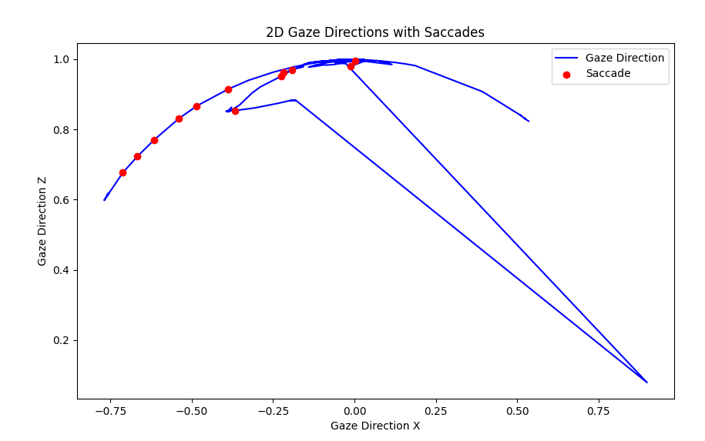

Figure 1 : Gaze Directions with Saccades.

## Research Design

The primary objective of this research is to identify and characterize eye movement patterns during a target object identification task in virtual reality (VR). The study will employ advanced eye-tracking technology to capture and analyze participants' gaze behavior as they engage in the specified task within the immersive VR environment.

For the experimental test case, we will present participants with two types of stimuli, encompassing objects of varying distances (near and far) within the virtual environment. The presentation of these stimuli is designed to examine how object size perception is influenced by contextual depth cues.



Figure 2 : Startup screen, the dice icon will generate a random id.

The first block protocol will include a VR scheme, warehouse scene with different types of furniture where stimuli can appear. In each trial, we will start by presenting fixation mark

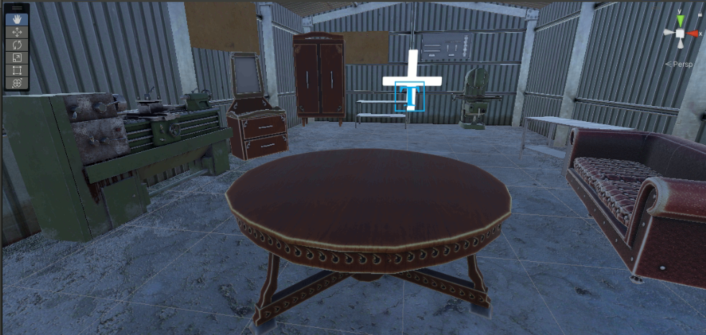

Figure 3 : The fixation screen in the middle of the warehouse scene mark with + .

(+) for 2000 ms, stimuli can randomly appear from the two categories (near / far) and will be positioned at different distances from the participant, 2 positions to the right of the fixation mark and 2 positions to the left with some random margin. The stimuli will appear an equal number of times on the left and right. Participants will be instructed to use the VR remote controller if they located the presented object. The participants will be required to register a click before the disappearance of the object. Failure to register a click until the end of the trial that will last for 2000 ms will be categorized as a “miss”.

Figure 3 : A toolbox as the target object presented on the near-left side.

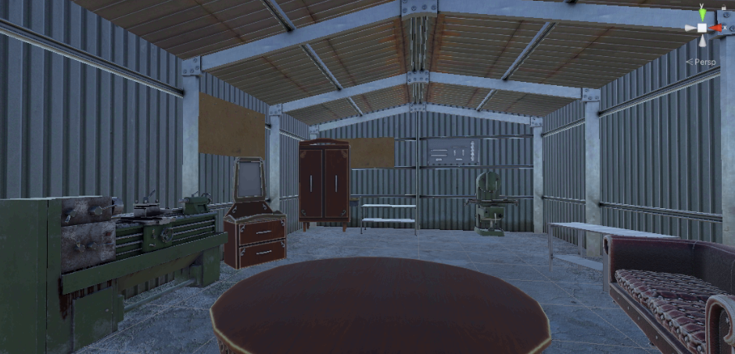

Figure 4 : A toolbox as the target object presented on the far-right side, next to the closet.

The second block will look the same as the first block only now we will add clutter, i.e., other objects that are not target objects. Clutter objects can appear in different positions in the scene.

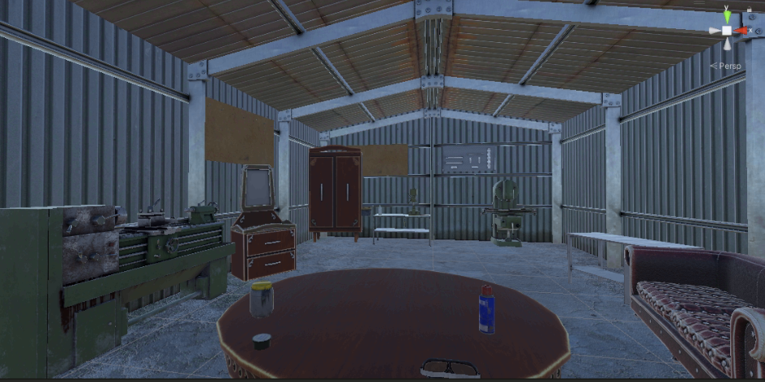

Figure 5 : target presented on the far-right with clutter objects presented both near and far.

Non-clutter and clutter scenarios will appear in alternating blocks of the task. Overall, we will conduct 8 blocks with 32 trials per block and a total of 256 trials.

## Apparatus/Materials

The VR environment was created using the Unity (version 2021.3.15f1) engine and was displayed through an HTC vive eyes pro headset. Eye movements were tracked using the same headset, which allows for precise measurement of fixation duration, saccade amplitude, and blink rate. A remote clicker as part of the HTC vive system was used to record participants' responses in the object detection task. Additional plugins that were used include SteamVR (version 2.7.4) and SRanipal (version 1.3.2.0), both crucial for collecting eye movement. A UXF (Unity Experiment Framework) [12] open source unity plugin was used to assist in developing the experiment by managing the experiment protocol and for data collection. Data was collected in the format of CSV in BIDS format. response times were logged each time a participant detected and clicked on an object. Misses were also marked. Eye-tracking data, including fixation duration, saccade amplitude, and gaze direction were collected and logged to a separate CSV file that was linked to the main session CSV file .

## Data Analysis

Each session, that is for each participant, a new folder is automatically crated that will hold the sessions results, results are saved to a CSV file, in this folder there will be another folder that holds the trackers inside for each trial we will have its own CSV file that holds eye tracking data.

The data was analyzed using Python in two stages. First, a script was employed to aggregate the data from all participants CSV files into a single CSV file. For each trial, this file contained summarized information from the external eye-tracking data, including the number of saccades, mean eye movement speed, and mean eye acceleration.

In the second stage, a subsequent script used this combined CSV file to calculate descriptive statistics for summarizing the data. Additionally, inferential statistical methods, such as t-tests, were applied to examine the effects of cognitive load, object positioning, and environmental clutter on eye movement metrics and response times.

# Results

Data was collected from 5 participants. Two participants were excluded from the analysis. One participant didn’t click the clicker, resulting in timeout of all trials. Another participant was interrupted during the collection of the data and partially completed only two blocks.

Fig 7 shows a summary of trial duration and eye-tracking data for each participant.

Figure 7 : Participants summary

Before computing descriptive and inferential statistics, I performed data cleaning. I’ve changed all string categories to integers and removed N/A.

## Descriptive Statistics

For each task condition, I computed basic descriptive statistic for each eye movement variable, including trial duration, saccades, eye movement speed. Next I compared averages between task conditions .

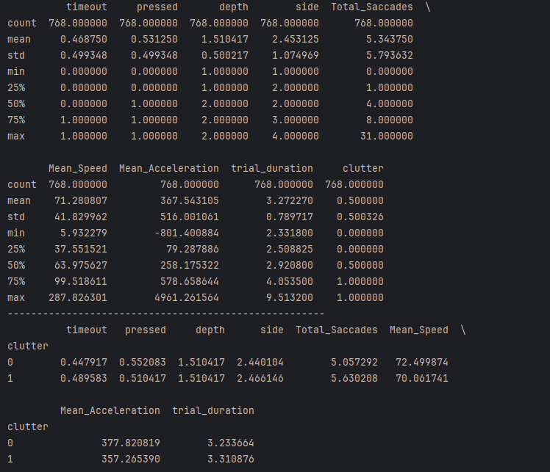

Figure 9 : Descriptive statistics

## Visualization

I created plots that examine how trial duration, total saccades, and other metrics vary by the side of the object and whether clutter was present or not.

### Trial Duration by Clutter and Side

Boxplots to show and compare how trial duration differs across the different side conditions near_left, near_right, far_left and far_right, and whether clutter was present. Similar trial durations were observed for all conditions. 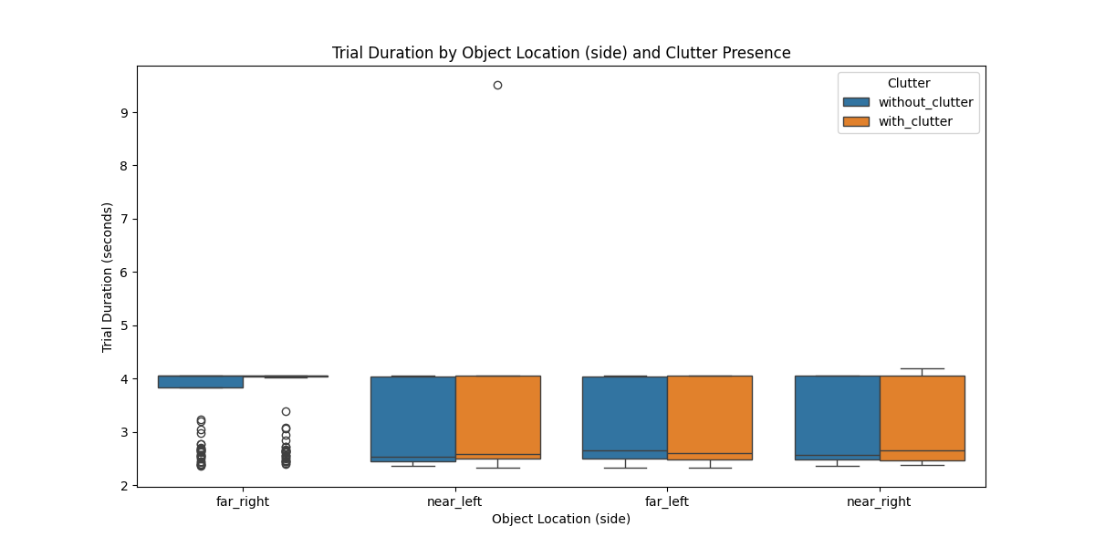

Figure 10 : Trial duration by clutter and side

### Total saccade by Clutter and Side

I created boxplots to show how the total number of eye saccades across the different side conditions near_left, near_right, far_left and far_right, and depending on whether clutter was present. Overall, We observed slightly more saccadic eye movements and longer trial durations when the object was placed near the participant. I believe this may be because the object, when near, is positioned outside of the participant's field of view (FOV), requiring additional effort to locate it. However, to confirm this observation, a statistical test would need to be performed. 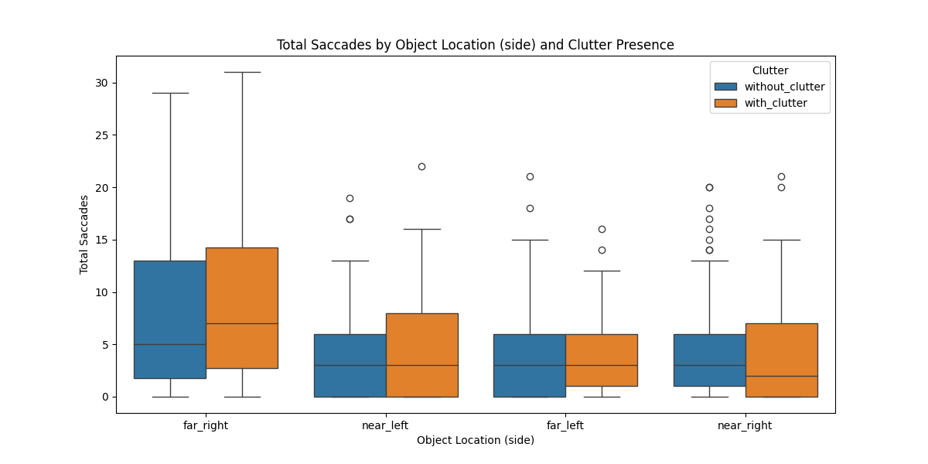

Figure 11 : Total saccade by clutter and side

### Pair plot

This plot allows us to see relationships between different metrics like trial_duration, Total_Saccades, etc. with the color coding based on clutter presence.  
The plots show that there is a correlation between saccade movement and mean speed / mean acceleration, as expected as both represent behavioral responses. Additionally, the number of saccades is positively correlated with trial duration.

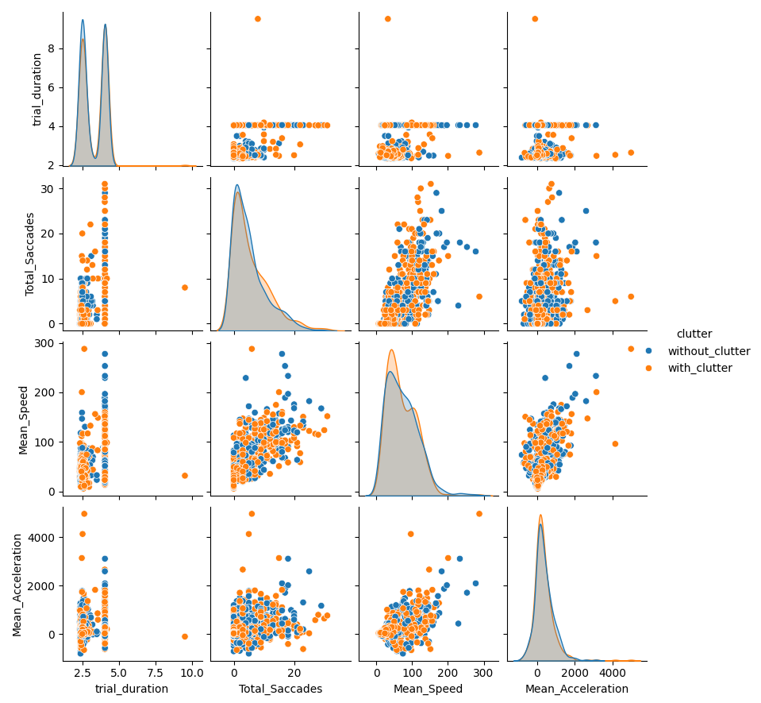

Figure 12 : Pair plot

### Heatmaps

I created a correlation matrix to see the relationships between different variables. Each entry in the matrix represents the correlation between two specific measurements. The matrix provides an overview indicating that there is no strong correlation between environmental clutter and trial duration, nor between the target object's placement and trial duration.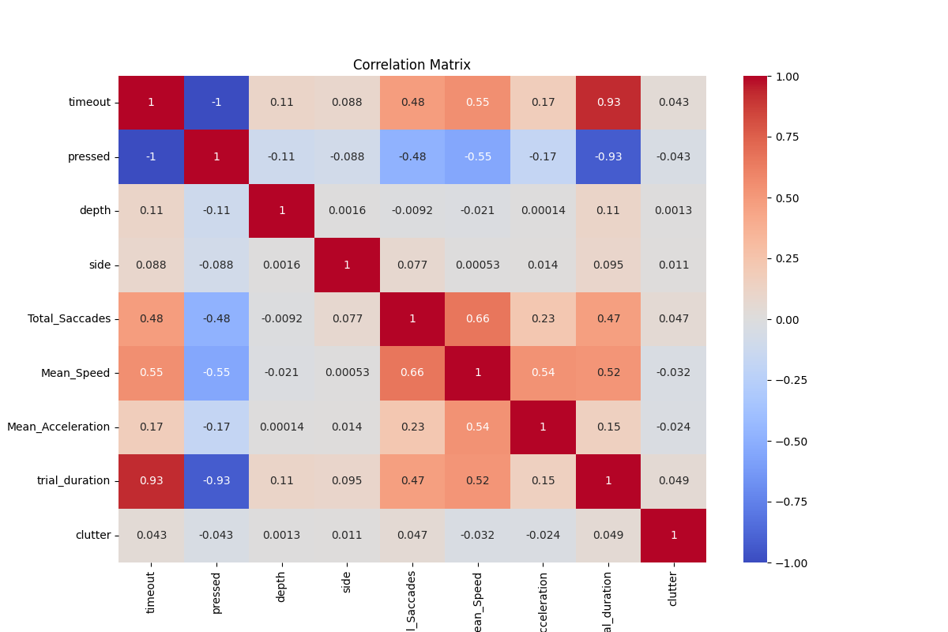

Figure 13 : Correlation matrix between different measures.

## Hypothesis Testing

I performed a series of t-tests and ANOVA tests to determine if there are significant differences in metrics like trial duration and total Saccades based on side and clutter conditions.

### T-tests for Clutter Presence

First, I’ve grouped the data into two groups with and without clutter, then I’ve ran t-test separately on trial duration and on number of saccades.

I’ve received the results presented in Fig 15. The p-value in both tests is much higher than 0.05, indicating that there is no statistically significant difference in the number of saccades or the total duration between the clutter and no-clutter conditions. This suggests that the presence of clutter does not significantly impact the number of saccades participants make nor the trait duration time.



Figure 15 : T-test results.

### ANOVA for Object Location

Given that side has multiple categories (near_left, near_right, far_left, far_right), and the performance from the above T-tests. I’ve tried to run an ANOVA test it may be more appropriate to check if there are significant differences across different object locations.

Both ANOVA tests show very low p-values (PR(>F)), meaning that the side in which the object is located significantly affects both the trial duration and the total number of saccades. In other words, the location of the object (near-left, near-right, far-left, far-right) has a meaningful impact on how long it takes for participants to complete a trial and how many saccades they make. The F-statistic values are high for both metrics, indicating that the effect of "Side" is not only statistically significant but also potentially substantial in explaining the variance in trial duration and total saccades.

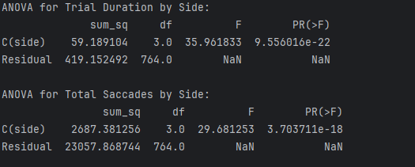

Figure 17 : ANOVA test results.

Given that the "Side" variable has a significant effect, I’ve conducted a post-hoc tests, Tukey's HSD to try and determine which specific sides differ from each other in terms of trial duration and total saccades. I’ve also added visualizations by creating box plots to visualize the effects of "Side" on these variables.

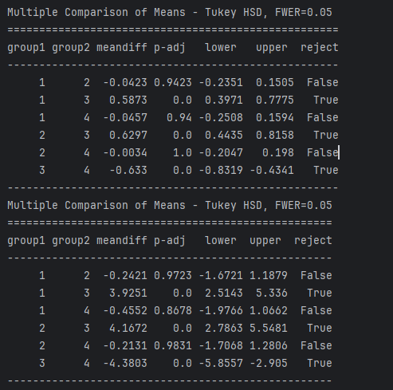

Figure 18 : Tukey's HSD test results the upper one is trial duration lower is total saccades.

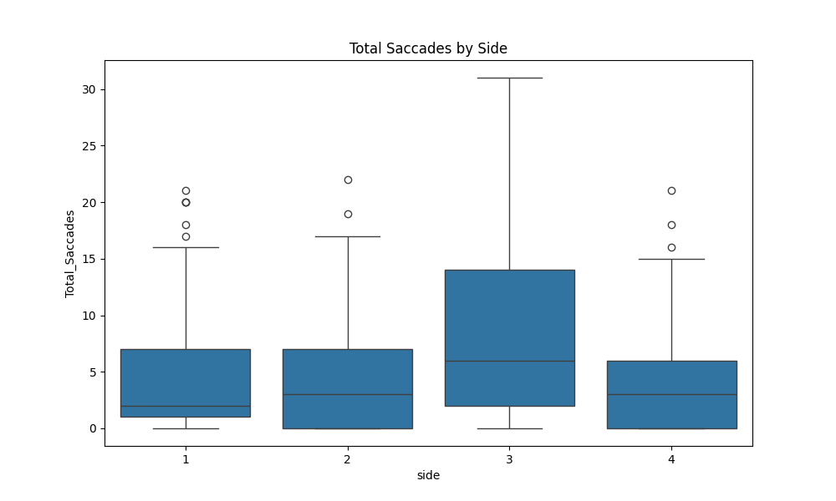

Figure 20 : Total saccades by side.

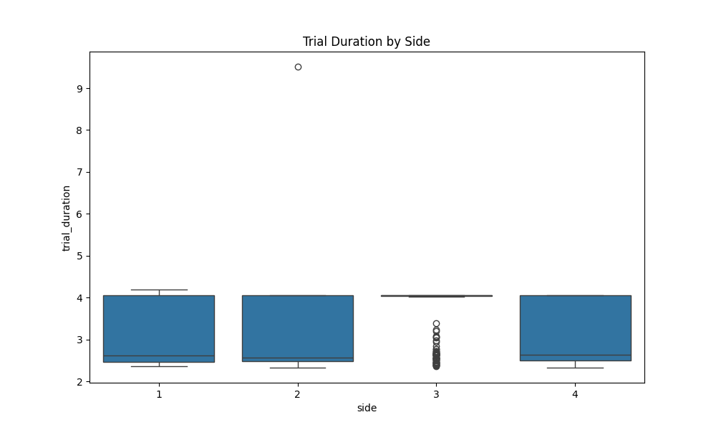

Figure 21 : Trial duration by side.

A reminder 'near_right': 1, 'near_left': 2, 'far_right': 3, 'far_left': 4. We notice that far_right continue to show outlier results compared to the other sides, it consistently shows longer trial durations, and more saccades compared to others. I need to further investigate.

On the other hand, far_left generally has shorter durations and fewer saccades, contrasting with Group 3. I’ll interpreter these results by concluding that overall, the “far” depth category shows less eye saccades and faster rection time. I’ll deduce this finding since the object is located inside the participants FOV while when present “near” it can be located outside the participants FOV and needs to move the head as well as the eyes to locate it.

### T-tests for Each Side with Clutter

Given previous results, "Side" variable has a significant effect, I’ve added another T-test for each of the sides for both total number of saccades and the trial duration.

Although the near-left condition shows a borderline effect for trial duration (p = 0.075), suggesting that clutter might have some impact, but the evidence is not strong enough to confirm a significant effect.

And across all four sides (far-right, near-left, far-left, near-right), the presence of clutter does not significantly affect trial duration or total saccades.

Therefore, Lack of Significant Differences might suggest that the clutter does not have a strong or consistent impact on user performance across different object locations. And further exploration is needed maybe to consider looking at interaction effects or conducting a power analysis to see if the study might need more participants or trials to detect a smaller effect.

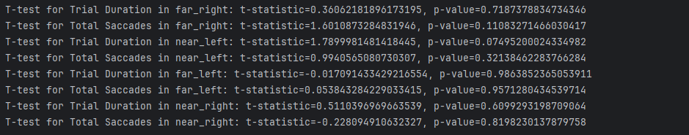

Figure 23 : t-test for each side.

### Synthetic data and machine learning.

As part of my analysis, I employed a logistic regression model to investigate whether the combination of eye movement features (i.e., 'trial_duration' and 'Total_Saccades') could predict the presence of clutter and the depth at which the object was placed. The rationale behind using a logistic regression model is that, although individual eye movement metrics may not show significant differences between conditions (e.g., clutter vs. no clutter), a multivariate approach could reveal patterns when these features are combined. This is particularly important in tasks involving complex cognitive load, where interactions between multiple variables may better capture the underlying processes.

To supplement the limited participant data, I developed an artificial data generator to simulate additional samples. This allows me to assess whether the current results are biased due to the small sample size. The artificial data closely mirrors the collected data and helps evaluate the robustness and generalizability of the logistic regression model's predictions.

Results on original data:

**Depth**:  
confusion matrix:

|  |  |
| --- | --- |
| 73 | 40 |
| 61 | 57 |

Classification report:

|  |  |  |  |
| --- | --- | --- | --- |
|  | | |  |
|  | | |  |
|  | | |  |
|  | | |  |
|  | | |  |
|  | | |  |
|  | | |  |
|  | | |  |
| **Metric** | **Value** | |
| Precision (near) | 0.54 | |
| Recall (near) | 0.65 | |
| F1-Score (near) | 0.59 | |
| Precision (far) | 0.59 | |
| Recall (far) | 0.48 | |
| F1-Score (far) | 0.53 | |
| Accuracy | 0.56 | |
| ROC-AUC Score | 0.6008 | |

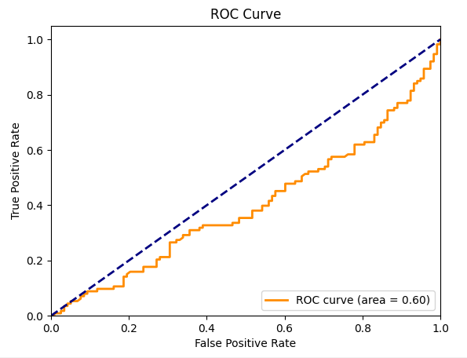

**Clutter**:  
confusion matrix:

|  |  |
| --- | --- |
| 61 | 55 |
| 63 | 52 |

Classification report:

|  |  |  |  |
| --- | --- | --- | --- |
|  | | |  |
|  | | |  |
|  | | |  |
|  | | |  |
|  | | |  |
|  | | |  |
|  | | |  |
|  | | |  |
| **Metric** | **Value** | |
| Precision (Clutter) | 0.49 | |
| Recall (Clutter) | 0.45 | |
| F1-Score (Clutter) | 0.47 | |
| Precision (No Clutter) | 0.49 | |
| Recall (No Clutter) | 0.53 | |
| F1-Score (No Clutter) | 0.51 | |
| Accuracy | 0.49 | |
| ROC-AUC Score | 0.438 | |

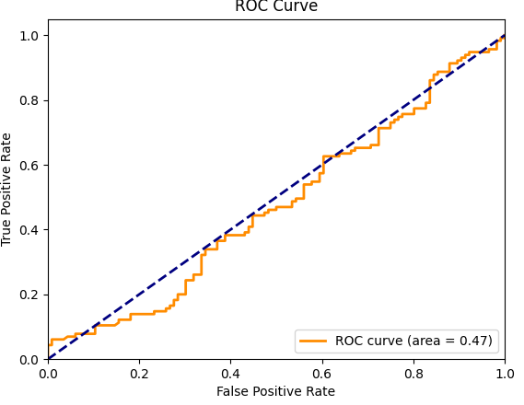

We can see that the model has moderate performance, with precision, recall, and f1-scores around 0.57-0.59. This indicates that the model is not particularly strong in distinguishing between 'Clutter' and 'No Clutter’ and between “Near” and “Far”, The confusion matrix shows that the model is about equally likely to make correct predictions as it is to make mistakes, with a slight bias towards predicting 'No Clutter' correctly and the same for “Near” category. The ROC-AUC suggests the model is slightly better than random guessing (0.5), much better in guessing the “depth” but still indicates that the model has room for improvement.

To examine if the small sample (n=3) is affecting the results I’ve used the same model on artificial data with the following parameters:

Figure 25 : generating synthetic data based on observed means and SD.

I’ve created 100000 synthetic data samples and re-run the two ML models giving the results presented in Figure 26. We can clearly see our performance to determine which depth the object was presented given only number of saccades and the time duration of the trial is much stronger now but the predicting the clutter based on those features is still low what can again imply that clutter will not affect this features.

Results on synthetic data:

**Depth**:  
confusion matrix:

|  |  |
| --- | --- |
| 10689 | 4263 |
| 4416 | 10632 |

Classification report:

|  |  |  |  |
| --- | --- | --- | --- |
|  | | |  |
|  | | |  |
|  | | |  |
|  | | |  |
|  | | |  |
|  | | |  |
|  | | |  |
|  | | |  |
| **Metric** | **Value** | |
| Precision (far) | 0.71 | |
| Recall (far) | 0.71 | |
| F1-Score (far) | 0.71 | |
| Precision (near) | 0.71 | |
| Recall (near) | 0.71 | |
| F1-Score (near) | 0.71 | |
| Accuracy | 0.71 | |
| ROC-AUC Score | 0.7857 | |

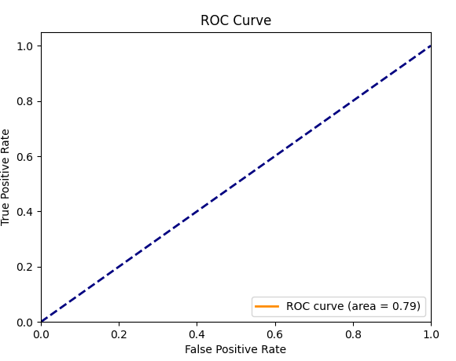

**Clutter**:  
confusion matrix:

|  |  |
| --- | --- |
| 6221 | 8773 |
| 6170 | 8836 |

Classification report:

|  |  |  |  |
| --- | --- | --- | --- |
|  | | |  |
|  | | |  |
|  | | |  |
|  | | |  |
|  | | |  |
|  | | |  |
|  | | |  |
|  | | |  |
| **Metric** | **Value** | |
| Precision (Clutter) | 0.50 | |
| Recall (Clutter) | 0.59 | |
| F1-Score (Clutter) | 0.54 | |
| Precision (No Clutter) | 0.50 | |
| Recall (No Clutter) | 0.41 | |
| F1-Score (No Clutter) | 0.45 | |
| Accuracy | 0.50 | |
| ROC-AUC Score | 0.5009 | |

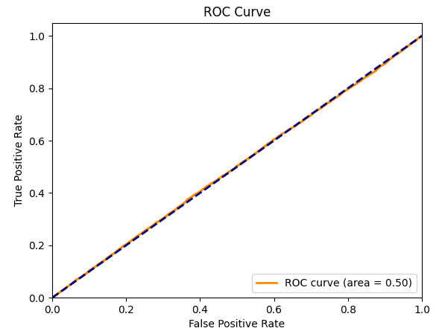

# Discussion

The experiment was based on two hypothesis . First, I thought that clutter will have impact of trial and this was not supported by the results. Second, I expected that objects that will be present far from user will impact both trial duration and the number of saccades. The results indicate a higher number of saccades when the object is presented at a near depth. This may be due to the object being outside the participant's field of view (FOV), requiring head movements to locate it. I hypothesize that this factor may have influenced the analysis of clutter effects. Previous studies have shown that clutter impacts reaction time, and I initially expected it to also increase the number of saccadic movements.

Depth results were also surprising as I expected that placing the object far from the user (meaning that the object would be smaller) will lead to more saccadic eye movements and will increase the duration of the trial. This was based on previous studies that showed that smaller objects should lead to more saccadic eye movement. For that, an additional study should be performed with an additional object, a much smaller object than the one that was used to examine specifically if using a much smaller object will increase the number of saccades or not. Importantly, my findings are limited due to the small sample size.

Enlarging the data sample using artificial data generator seems not to implicit major affect more than random guessing which means overall that I’ve chose weak features or I have unbalanced classes.

# Conclusion

In conclusion, this study achieved its primary objective of developing an integrative framework that combines VR technology with eye-tracking measurements to monitor attentional focus in naturalistic environments. We successfully demonstrated the feasibility of collecting and analyzing eye-tracking data within immersive VR scenarios, providing a robust foundation for studying attention in real-world-like conditions. The primary findings for my test case indicate that the depth of the object and presence of clutter both does not appear to have a substantial effect. These results were consistent across both the original dataset, which included data from three participants, and the analysis of 10,000 synthetic samples using logistic regression.

The finding that object depth, rather than clutter, impacts eye movement and response times has important implications for the design of virtual environments trials. It suggests that when designing tasks where visual search efficiency is crucial, attention should be given to the spatial arrangement and depth of objects. This is particularly relevant in fields such as military training, aviation, and education, where understanding how depth affects cognitive load could lead to more effective training scenarios for example.

One of the key limitations of this study is the small sample size of the original data. However, a central objective of the study was to develop the experimental paradigm and framework, as well as to explore the feasibility of using eye-tracking data from the VR system. The study was not primarily designed to draw definitive conclusions from the results. Achieving stronger statistical power would require a significantly larger sample size, which was beyond the scope of this initial investigation. It is important to emphasize this point to clarify the study's focus and limitations. Additionally, the study was conducted using only one object size, which may not fully capture the range of possible effects on eye movement and cognitive load.

Future research could explore the impact of varying object sizes on eye movement patterns to determine if smaller objects might influence cognitive load differently. Expanding the participant pool and including a more diverse range of scenarios could also help validate the findings and explore the effects of clutter in more complex environments. Additionally, further studies could investigate the interactions between depth and other environmental factors in more detail.

This study contributes to the understanding of how cognitive load influences eye movement in virtual environments, particularly concerning the depth of objects. While clutter did not appear to have a significant effect, the findings highlight the importance of considering depth in the design of VR environments.

# . References

[1] E. Upenik and T. Ebrahimi, “A simple method to obtain visual attention data in head mounted virtual reality,” in *2017 IEEE International Conference on Multimedia & Expo Workshops (ICMEW)*, Hong Kong, Hong Kong: IEEE, Jul. 2017, pp. 73–78. doi: 10.1109/ICMEW.2017.8026231.

[2] F. Borgnis *et al.*, “Available Virtual Reality-Based Tools for Executive Functions: A Systematic Review,” *Front. Psychol.*, vol. 13, p. 833136, Apr. 2022, doi: 10.3389/fpsyg.2022.833136.

[3] I. B. Adhanom, P. MacNeilage, and E. Folmer, “Eye Tracking in Virtual Reality: a Broad Review of Applications and Challenges,” *Virtual Real.*, vol. 27, no. 2, pp. 1481–1505, Jun. 2023, doi: 10.1007/s10055-022-00738-z.

[4] H. Park, N. Faghihi, M. Dixit, J. Vaid, and A. McNamara, “Judgments of Object Size and Distance across Different Virtual Reality Environments: A Preliminary Study,” *Appl. Sci.*, vol. 11, no. 23, p. 11510, Dec. 2021, doi: 10.3390/app112311510.

[5] S. H. Creem-Regehr, J. K. Stefanucci, and B. Bodenheimer, “Perceiving distance in virtual reality: theoretical insights from contemporary technologies,” *Philos. Trans. R. Soc. B Biol. Sci.*, vol. 378, no. 1869, p. 20210456, Jan. 2023, doi: 10.1098/rstb.2021.0456.

[6] S. Masarwa, O. Kreichman, and S. Gilaie-Dotan, “Larger images are better remembered during naturalistic encoding,” *Proc. Natl. Acad. Sci.*, vol. 119, no. 4, p. e2119614119, Jan. 2022, doi: 10.1073/pnas.2119614119.

[7] A. Borji, M.-M. Cheng, Q. Hou, H. Jiang, and J. Li, “Salient object detection: A survey,” *Comput. Vis. Media*, vol. 5, no. 2, pp. 117–150, Jun. 2019, doi: 10.1007/s41095-019-0149-9.

[8] Y. Erez and G. Yovel, “Clutter modulates the representation of target objects in the human occipitotemporal cortex,” *J. Cogn. Neurosci.*, vol. 26, no. 3, pp. 490–500, Mar. 2014, doi: 10.1162/jocn_a_00505.

[9] Q. Sun *et al.*, “Towards virtual reality infinite walking: dynamic saccadic redirection,” *ACM Trans. Graph.*, vol. 37, no. 4, pp. 1–13, Aug. 2018, doi: 10.1145/3197517.3201294.

[10] L. Kumle, M. L.-H. Võ, A. C. Nobre, and D. Draschkow, “Multifaceted consequences of visual distraction during natural behaviour,” *Commun. Psychol.*, vol. 2, no. 1, pp. 1–13, May 2024, doi: 10.1038/s44271-024-00099-0.

[11] R. L. Hornsey, P. B. Hibbard, and P. Scarfe, “Size and shape constancy in consumer virtual reality,” *Behav. Res. Methods*, vol. 52, no. 4, pp. 1587–1598, Aug. 2020, doi: 10.3758/s13428-019-01336-9.

[12] J. Brookes, M. Warburton, M. Alghadier, M. Mon-Williams, and F. Mushtaq, “Studying human behavior with virtual reality: The Unity Experiment Framework,” *Behav. Res. Methods*, vol. 52, no. 2, pp. 455–463, Apr. 2020, doi: 10.3758/s13428-019-01242-0.

# Appendices

All Unity scripts, data processing scripts, and synthetic data are included in a github repository: https://github.com/shushkis/final_project.git